K.POOJA SREE
192512245
ECA5801-IOE AND AI DRIVEN SYSTEM
SIMULATION
EXPERIMENT 6.A
A.Simulation and Performance Evaluation of People–Process–Data–Things IoE Framework using Edge/Fog-to-Cloud Pipeline with MQTT, Node-RED.

CODE:
# ============================================================
# EXPERIMENT 6(a)
# Simulation and Performance Evaluation of P-P-D-T IoE
# Framework using Edge/Fog-to-Cloud Pipeline with MQTT,
# Node-RED and 5G/6G
# ============================================================

import numpy as np
import pandas as pd
import matplotlib.pyplot as plt

np.random.seed(42)

# ------------------------------------------------------------
# 1. P-P-D-T DATA FLOW
# ------------------------------------------------------------

ppdt = ["People", "Process", "Data", "Things"]

print("========== P-P-D-T IoE DATA FLOW ==========\n")
print(" → ".join(ppdt))
print("\nPeople → Process → Data → Things")
print(" ↓")
print(" MQTT")
print(" ↓")
print(" Edge → Fog → Cloud")
print(" ↓")
print(" Node-RED")

# ------------------------------------------------------------
# 2. EDGE / FOG / CLOUD PARAMETERS
# ------------------------------------------------------------

layers = ["Edge", "Fog", "Cloud"]

# Processing capacity in Mbps
capacity = {
"Edge": 100,
"Fog": 75,
"Cloud": 50
}

# Base latency in milliseconds
base_latency = {
"Edge": 10,
"Fog": 25,
"Cloud": 60
}

# Packet loss probability
loss_rate = {
"Edge": 0.02,
"Fog": 0.04,
"Cloud": 0.06
}

# ------------------------------------------------------------
# 3. SIMULATION
# ------------------------------------------------------------

total_packets = 1000
packet_size_kb = 2
simulation_time = 10

results = []

for layer in layers:

lost_packets = int(total_packets * loss_rate[layer])
delivered_packets = total_packets - lost_packets

# Data successfully delivered
data_bits = delivered_packets * packet_size_kb * 8 * 1024

# Throughput
throughput = data_bits / simulation_time / 1e6

# Limit according to layer capacity
throughput = min(throughput, capacity[layer])

# Latency
latency = base_latency[layer] + np.random.uniform(2, 8)

results.append([
layer,
total_packets,
delivered_packets,
throughput,
latency
])

# ------------------------------------------------------------
# 4. RESULT TABLE
# ------------------------------------------------------------

df = pd.DataFrame(
results,
columns=[
"Layer",
"Total Packets",
"Delivered Packets",
"Throughput (Mbps)",
"Latency (ms)"
]
)

df["Throughput (Mbps)"] = df["Throughput (Mbps)"].round(2)
df["Latency (ms)"] = df["Latency (ms)"].round(2)

print("\n========== EDGE / FOG / CLOUD RESULTS ==========\n")
display(df)

# ------------------------------------------------------------
# 5. THROUGHPUT GRAPH
# ------------------------------------------------------------

plt.figure(figsize=(6, 4))

plt.bar(
df["Layer"],
df["Throughput (Mbps)"]
)

plt.title("Edge / Fog / Cloud - Throughput")
plt.xlabel("Processing Layer")
plt.ylabel("Throughput (Mbps)")
plt.grid(axis="y", alpha=0.3)

plt.show()

# ------------------------------------------------------------
# 6. LATENCY GRAPH
# ------------------------------------------------------------

plt.figure(figsize=(6, 4))

plt.bar(
df["Layer"],
df["Latency (ms)"]
)

plt.title("Edge / Fog / Cloud - Latency")
plt.xlabel("Processing Layer")
plt.ylabel("Latency (ms)")
plt.grid(axis="y", alpha=0.3)

plt.show()

# ------------------------------------------------------------
# 7. 5G vs 6G COMPARISON
# ------------------------------------------------------------

network = ["5G", "6G"]

network_throughput = [1000, 5000]
network_latency = [10, 1]

network_df = pd.DataFrame({
"Network": network,
"Throughput (Mbps)": network_throughput,
"Latency (ms)": network_latency
})

print("\n========== 5G vs 6G ==========\n")
display(network_df)

# ------------------------------------------------------------
# 8. 5G / 6G GRAPHS
# ------------------------------------------------------------

fig, ax = plt.subplots(1, 2, figsize=(9, 4))

ax[0].bar(
network_df["Network"],
network_df["Throughput (Mbps)"]
)

ax[0].set_title("5G vs 6G Throughput")
ax[0].set_ylabel("Mbps")

ax[1].bar(
network_df["Network"],
network_df["Latency (ms)"]
)

ax[1].set_title("5G vs 6G Latency")
ax[1].set_ylabel("ms")

plt.tight_layout()
plt.show()

# ------------------------------------------------------------
# 9. CONCLUSION
# ------------------------------------------------------------

print("\n========== CONCLUSION ==========\n")

print("1. Edge processing provides lower latency because")
print(" processing occurs close to IoE devices.")

print("\n2. Fog acts as an intermediate layer between Edge and Cloud.")

print("\n3. Cloud processing generally introduces higher latency")
print(" because data travels farther.")

print("\n4. In this simulation, 6G provides higher throughput")
print(" and lower latency than 5G.")

print("\n5. MQTT is used as the communication concept and")
print(" Node-RED represents the IoE data-flow/workflow layer.")

OUTPUT:
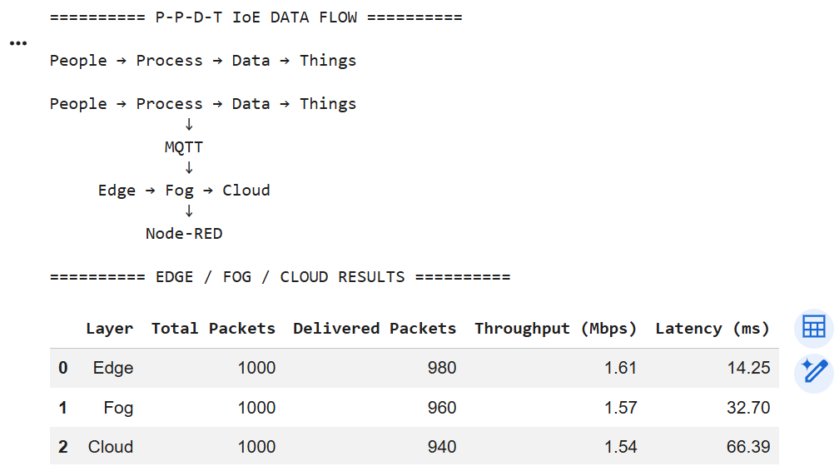
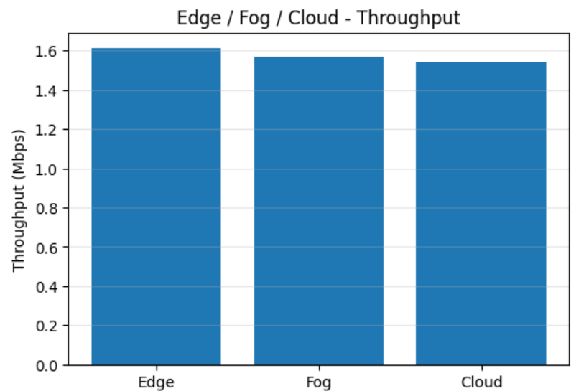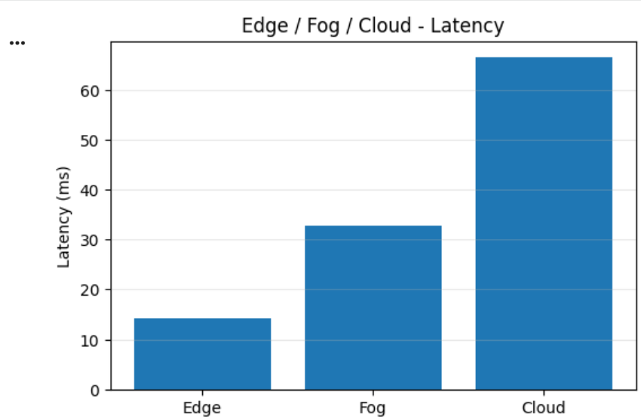
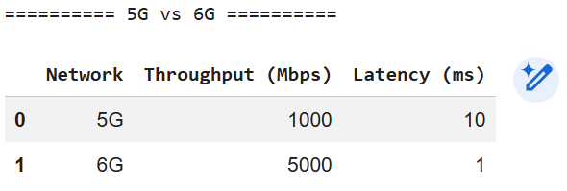
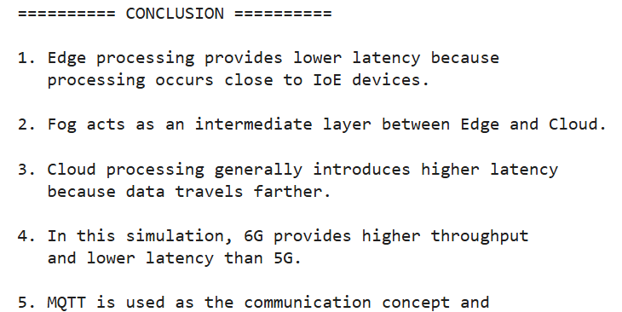

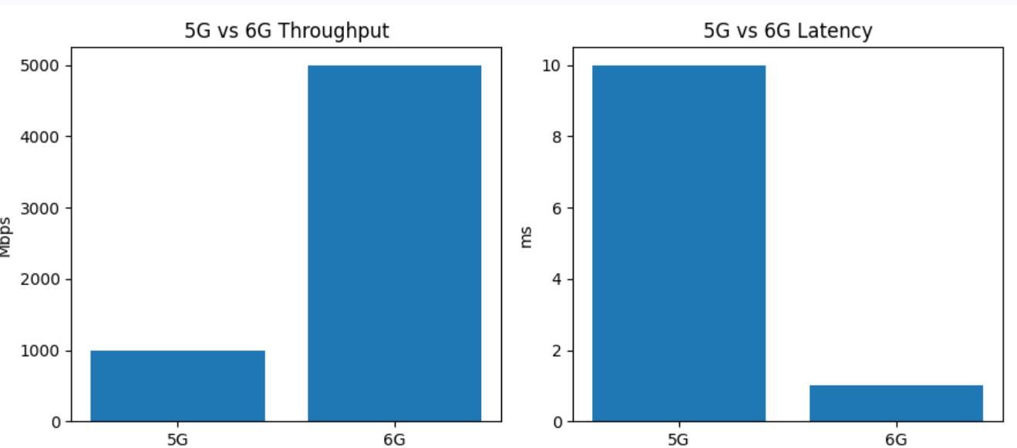

EXPERIMENT 6.B
K.POOJA SREE
192512245
B.Benchmarking of 5G/6G Communication for IoE Applications based on Throughput, Latency, Reliability and Energy Efficiency
CODE:
# ============================================================
# EXPERIMENT 6(b)
# Benchmarking of 5G/6G Communication for IoE Applications
# based on Throughput, Latency, Reliability and Energy Efficiency
# ============================================================

import numpy as np
import pandas as pd
import matplotlib.pyplot as plt

# ------------------------------------------------------------
# 1. NETWORKS
# ------------------------------------------------------------

networks = ["5G", "6G"]

# Representative simulation parameters
throughput = [1000, 5000] # Mbps
latency = [10, 1] # ms
reliability = [99.0, 99.99] # %
energy_efficiency = [70, 90] # %

# ------------------------------------------------------------
# 2. RESULT TABLE
# ------------------------------------------------------------

df = pd.DataFrame({
"Network": networks,
"Throughput (Mbps)": throughput,
"Latency (ms)": latency,
"Reliability (%)": reliability,
"Energy Efficiency (%)": energy_efficiency
})

print("========== 5G vs 6G BENCHMARK RESULTS ==========\n")

display(df)

# ------------------------------------------------------------
# 3. THROUGHPUT
# ------------------------------------------------------------

plt.figure(figsize=(6, 4))

plt.bar(
df["Network"],
df["Throughput (Mbps)"]
)

plt.title("5G vs 6G - Throughput")
plt.xlabel("Network")
plt.ylabel("Throughput (Mbps)")
plt.grid(axis="y", alpha=0.3)

plt.show()

# ------------------------------------------------------------
# 4. LATENCY
# ------------------------------------------------------------

plt.figure(figsize=(6, 4))

plt.bar(
df["Network"],
df["Latency (ms)"]
)

plt.title("5G vs 6G - Latency")
plt.xlabel("Network")
plt.ylabel("Latency (ms)")
plt.grid(axis="y", alpha=0.3)

plt.show()

# ------------------------------------------------------------
# 5. RELIABILITY
# ------------------------------------------------------------

plt.figure(figsize=(6, 4))

plt.bar(
df["Network"],
df["Reliability (%)"]
)

plt.title("5G vs 6G - Reliability")
plt.xlabel("Network")
plt.ylabel("Reliability (%)")
plt.ylim(95, 100)

plt.grid(axis="y", alpha=0.3)

plt.show()

# ------------------------------------------------------------
# 6. ENERGY EFFICIENCY
# ------------------------------------------------------------

plt.figure(figsize=(6, 4))

plt.bar(
df["Network"],
df["Energy Efficiency (%)"]
)

plt.title("5G vs 6G - Energy Efficiency")
plt.xlabel("Network")
plt.ylabel("Energy Efficiency (%)")

plt.grid(axis="y", alpha=0.3)

plt.show()

# ------------------------------------------------------------
# 7. COMBINED GRAPH
# ------------------------------------------------------------

fig, ax = plt.subplots(2, 2, figsize=(9, 7))

ax[0, 0].bar(
df["Network"],
df["Throughput (Mbps)"]
)
ax[0, 0].set_title("Throughput")
ax[0, 0].set_ylabel("Mbps")

ax[0, 1].bar(
df["Network"],
df["Latency (ms)"]
)
ax[0, 1].set_title("Latency")
ax[0, 1].set_ylabel("ms")

ax[1, 0].bar(
df["Network"],
df["Reliability (%)"]
)
ax[1, 0].set_title("Reliability")
ax[1, 0].set_ylabel("%")
ax[1, 0].set_ylim(95, 100)

ax[1, 1].bar(
df["Network"],
df["Energy Efficiency (%)"]
)
ax[1, 1].set_title("Energy Efficiency")
ax[1, 1].set_ylabel("%")

plt.tight_layout()
plt.show()

# ------------------------------------------------------------
# 8. AUTOMATIC COMPARISON
# ------------------------------------------------------------

print("\n========== PERFORMANCE COMPARISON ==========\n")

if throughput[1] > throughput[0]:
print("✓ 6G has higher throughput than 5G.")

if latency[1] < latency[0]:
print("✓ 6G has lower latency than 5G.")

if reliability[1] > reliability[0]:
print("✓ 6G has higher reliability than 5G.")

if energy_efficiency[1] > energy_efficiency[0]:
print("✓ 6G has better energy efficiency than 5G.")

# ------------------------------------------------------------
# 9. FINAL CONCLUSION
# ------------------------------------------------------------

print("\n========== CONCLUSION ==========\n")

print("6G shows better simulated performance than 5G")
print("for IoE applications in this benchmark.")
print("\n• Higher throughput")
print("• Lower latency")
print("• Higher reliability")
print("• Better energy efficiency")
OUTPUT:
